#1(My Profile):

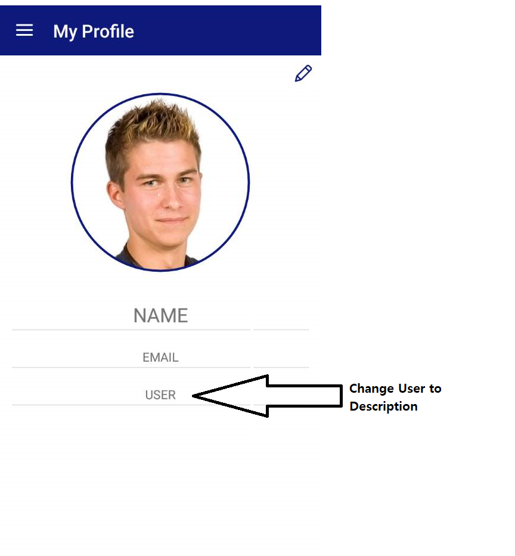

Akilan: Have corrected. Please check and share your feedback

#2:

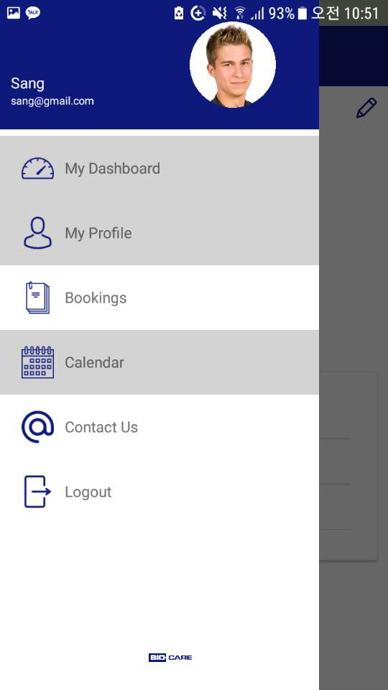

Make the font of the words(My Dashboard, My Profile, Bookings, Calendar, Contact Us, Logout) into blue (same color as the icons)

Akilan: Have corrected. Please check and share your feedback

Akilan: I’ve updated. Please check



Make the Bio-Care Logo at the bottom bigger.

Akilan: Have changed it. Please check